**CLASSIFICATION OF IMAGES BASED ON MEMORABLE SCORE**

Harsha Priya G

2019207029

M.E CSE

**Guided By**

Dr V. Mary Anita Rajam

Professor

Department of Computer Science and Engineering

Anna University

**Date :** 23-09-2020 **Signature**

**a. INTRODUCTION**

In today's world we deal with more images from capturing images in mobile phones to the Google Image search. All most all people would have use or using the images in one part of their life or other. Despite this overflow of visual information, humans are extremely good at remembering thousands of pictures along with some of their visual details. But not all images are equal in memory. Some stitch to our minds, and other are forgotten. Currently ,there is only an optimality in text searchers but the predictability of which part of an image is memorable is not in extensive use.

**b. PROBLEM STATEMENT**

The focus is of the project is predicting how memorable an image will be? using Computer vision techniques and Visual Memory Schema to serve the purpose of enhancing the human understandability, diagnose memory problems, for effective retrieval of image search, Computer Graphics and summarization of Big data images and videos etc...

We understand that memorability is a stable property of an image that is shared across different viewers. A database is introduced with the measured probability that each picture will be remembered after a single view. We then analyze image features and labels that contribute to making an image memorable, and train a predictor based on global image descriptors .We finally find that predicting image memorability is a task that can be addressed with current computer vision techniques.

**c. LITERATURE SURVEY**

E. Tulving in his work, “Organization of memory” best describes how memories play an important role in learning. The work emphasises more on how the memories form the essential component to define ourselves [1]

T. F. Brady et’al on their work “A review of visual memory capacity: Beyond individual items and toward structured representations” illustrates the human memory capacity for visual information absorption and retrieval of images from the memory.[2]

L. Standing et’al on their work “Verbal-pictorial transformations in recognition memory” performed two experiments during which subjects learned either footage or descriptions of footage of images and they’re then tested for recognition with either pictures or descriptions, altogether four mixtures. Recognition was best within the Picture-Picture condition, intermediate within the Picture-Word and Word-Word conditions which failed to take issue significantly, and worst within the Word-Picture condition. the additional variety of errors accessorial by dynamical to a metamorphosis condition (Picture-Word or Word-Picture) from the corresponding non-transformation condition (Picture-Picture or Word-Word respectively), was constant in either case. A model for recognition memory is projected that postulates that each pictorial stimuli and descriptive verbal stimuli are encoded in a very pictorial (or functionally equivalent) kind to that later transformations could also be applied by the experimental task. This model uses 2 parameters: a coffee background level related to pictorial secret writing and storage, and the next background level related to creating a verbal-pictorial transformation (or vice versa). The model is supported by a re-analysis of the information of Jenkins, Neale, and Deno (1967) and by the information of the 2 gift experiments. a further question, the chance of twin process of verbal and pictorial stimuli, was examined by using each footage and descriptions at the same time within the learning session and/or the take a look at the session. proof suggesting stereophonic operation was obtained in 3 out of 5 experimental conditions.[3]

P. Isola et’al on the work “Understanding the intrinsic memorability of images,” in conference on Neural information processing Systems, explained how the images exhibit the intrinsic property. Artists, advertisers, and photographers square measure habitually given with the task of making a picture can bear in mind ,whereas it's going to seem to be image memorability is only subjective, recent work shows that it's not associate degree paradoxical phenomenon: variation in memorability of pictures is consistent across subjects, suggesting that some pictures square measure in and of itself a lot of unforgettable than others, freelance of a subjects' contexts and biases. During this paper work, they tend to use the publically offered memorability dataset of Isola et al., and increased the article and scene annotations with explainable spatial, content, and they tend to used a feature-selection theme with fascinating explaining-away properties to work out a compact set of attributes that characterizes the memorability of any person image. They discover that pictures of fogbound areas containing folks with visible faces square measure unforgettable, whereas pictures of vistas and peaceful scenes don't seem to be. Contrary to fashionable belief, uncommon or esthetical pleasing scenes don't tend to be extremely unforgettable. This work represents one in all the primary tries at understanding intrinsic image memorability, and opens a replacement domain of investigation at the interface between human knowledge and pc vision. [4]

Z. Bylinskii et’al work on “Intrinsic and extrinsic effects on image memorability” ,explains how the intrinsic and extrinsic effects on image memorability. Previous studies have known that pictures carry the attribute of memorability, a prophetical worth of whether or not a unique image are going to be later remembered or forgotten. Here the work has a tendency to investigate the interaction between intrinsic and foreign factors that have an effect on image memorability. Firstly, they discovered that intrinsic variations in memorability exist at a finer-grained scale than antecedent documented. Secondly, they checked 2 foreign factors: image context and observer behaviour. Building on previous findings that pictures that area unit distinct with regard to their context area unit higher remembered, they proposed associate degree information-theoretic model of .Their model mechanically predicted amendments in the context change of the memorability of natural pictures. Additionally to context, they studied a second foreign factor: wherever associate degree observer appearance whereas memorizing a picture. It seems that eye movements give extra info which will predict whether or not or not a picture are going to be remembered, on a trial-by-trial basis. [5]

A. Oliva et’al work on “A holistic representation of the spatial envelope”, explains how to model the shape of the scene using a holistic representation of the spatial envelope. In this paper, their work tend to propose a process model of the popularity of universe scenes that bypasses the segmentation and also the process of individual objects or regions. The procedure relies on a awfully low dimensional illustration of the scene, that their work tend to term the abstraction Envelope their work tend to propose a collection of sensory activity dimensions(naturalness, openness, roughness, expansion, ruggedness) that represent the dominant abstraction structure of a scene. Then, their work tend to show that these dimensions is also dependably calculable exploitation spectral and coarsely localized info. The model generates a multidimensional area during which scenes sharing membership in linguistics classes (e.g., streets, highways, coasts) are projected closed along. The performance of the abstraction envelope model shows that specific info regarding object form or identity isn't a demand for scene categorization which modelling a holistic illustration of the scene informs regarding its probable linguistics class. [6]

**d. LIST OF MODULES**

1. Feature Extraction and Memorability Measure
2. Split of Train and Testing data
3. Consistency Analysis
   1. Image Consistency
   2. Human Consistency
4. What Makes an Image Memorable?
   1. Color and Simple Image Feature Analysis
   2. Non Semantics Object Statistics
5. What Classes of an Image Predict Memorability?
6. Memorability Map Visual Memorability Map
7. Automatic Predictions

**d. OVERALL DETAILED ARCHITECUTE DIAGRAM WITH LIST OF MODULES**

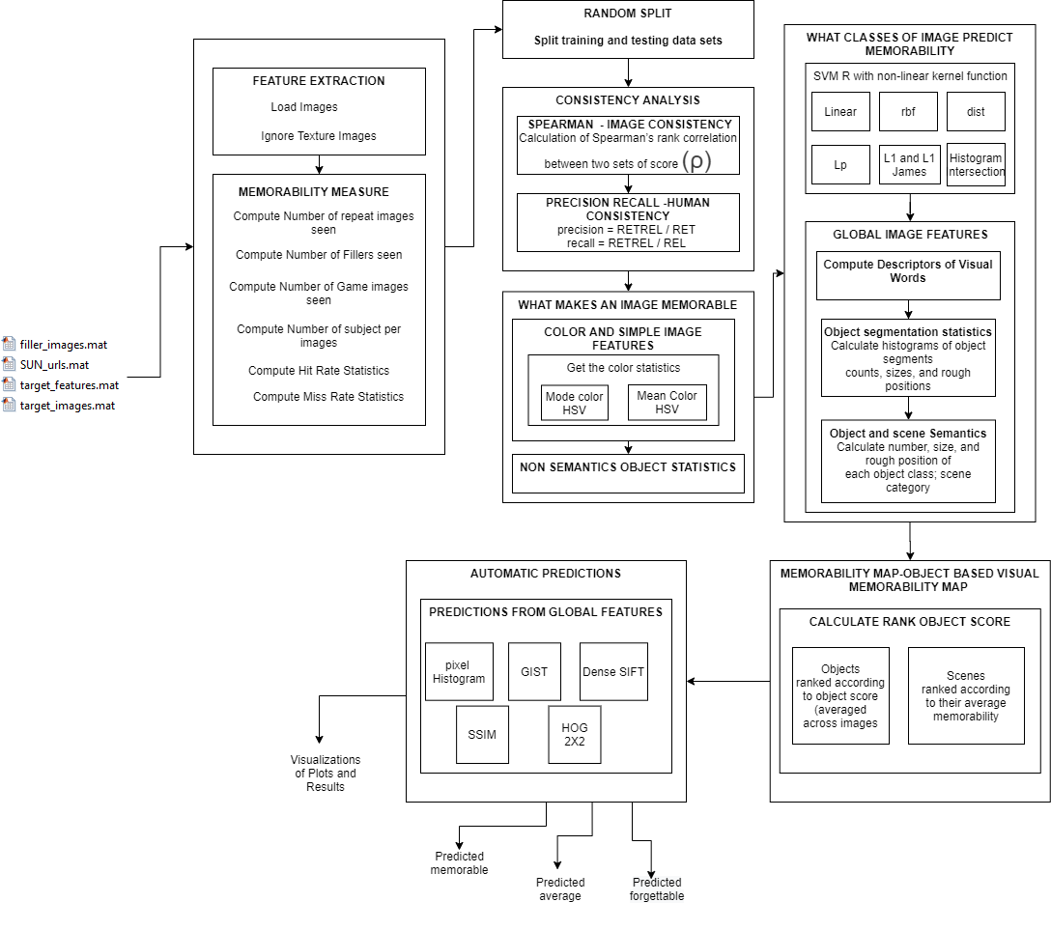

**e. MODULE SPLIT UP**

**DETAILED ARCHITECTURE DIAGRAM MODULE WISE SPILT UP – FEATURE EXTRACTION AND MEASURING MEMORABILITY(1)**

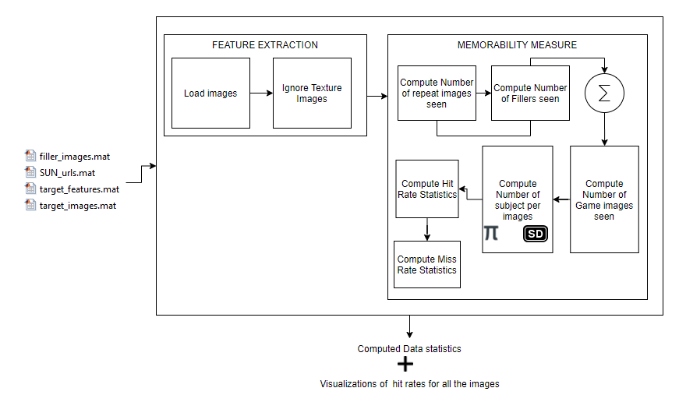

**PSEUDOCODE FOR FEATURE EXTRACTION AND MEASURING MEMORABILITY**

Step 1: Input the database in matrix form consisting of images with probability that each image will be remembered after a single View

Step 2:Load the images and ignore the Texture Images for Feature extraction

Step 3 :Compute Memorability Measure:

1. Compute Number of repeat images seen
2. Compute Number of Filler images seen
3. Compute Number of Game images seen
4. Compute Number of Subjects per image
5. Compute Hit Rate Statistics
6. Compute Miss Rate Statistics

Step 4: Get the computed Memorability Score and Visualizations

**Thus, memorability scores are a good measure of correct memories.**

**DETAILED ARCHITECTURE DIAGRAM MODULE WISE SPLIT UP – RANDOM SPLITS(2)**

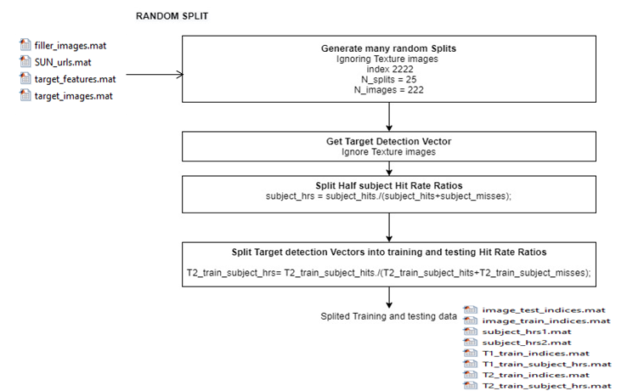

**PSEUDOCODE FOR RANDOM SPLITS**

Step 1**:** Input the database in matrix form consisting of images with probability that each image will be remembered after a single View

Step 2 :Generate many random splits

Step 3: Get the target detection vector and Ignore the texture images

Step 4: Split Half subject Hit Rate Ratio

Step 5 : Split the target detection Vectors into training and testing Hit Rate Ratios

Step 6: Output consists of Splited training and testing data in matrix format.

**DETAILED ARCHITECTURE DIAGRAM MODULE WISE SPLIT UP – CONSISTENCY ANALYSIS(3)**

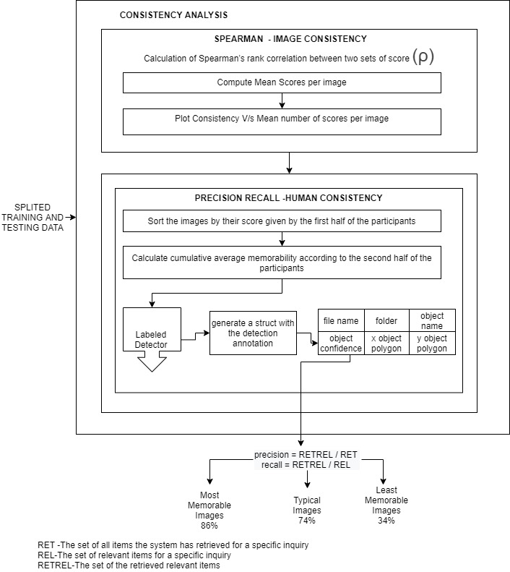

**PSEUDOCODE FOR CONSISTENCY ANALYSIS**

Step 1: Input the Splited training and testing images for analysis of consistency model

Step 2 : Compute the Spearman's Rank Correlation for image Consistency analysis

1. Compute Mean Scores per Images
2. Compute Consistency of Image

Step 3: Compute Precision Recall for Human Consistency Analysis

1. Sort the images by their score given by the first half of the participants
2. Calculate the cumulative average memorability according to the second half of the participants
3. Use the Object detector function to generate the structure with the detection annotation
4. Get the object Confidence and compute the precision Recall

Output: The percent of times that these images were remembered by an independent set of participants.

**This analysis shows how high human-to-human memorability consistency can be. Thus, our data has enough consistency that it should be possible to predict image memorability.**

**DETAILED ARCHITECTURE DIAGRAM MODULE WISE SPLIT WHAT MAKES IMAGE MEMORABLE?(4)**

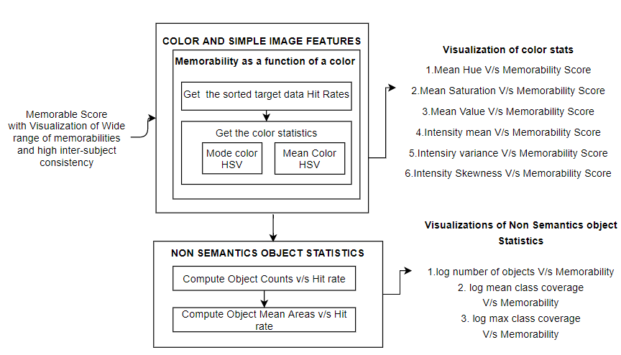

**PSEUDOCODE FOR WHAT MAKES IMAGE MEMORABLE?**

Step 1: Input the system with Memorable Score with Visualization of Wide range of memorabilities and high inter subject consistency

Step 2: Color and Simple image feature analysis using memorability as a function of a color

1. Get the sorted target data Hit Rates
2. Get the color Statistics
   * + - 1. Compute Mode Color Histogram Vector
         2. Compute Mean Color Histogram Vector

Step 3: Compute the Non-Semantics Object Statistics

* + - * 1. Compute Object Counts V/s Hit Rate
        2. Compute Object mean Area V/s Hit Rate

Output:

Visualizations of Color Statistics and Non Schematics Object Statistics

**Do such statistics predict memorability? Simple image features, as well as non-semantic object statistics, do not correlate strongly with memorability score.**

**DETAILED ARCHITECTURE DIAGRAM MODULE WISE WHAT CLASSES OF IMAGE PREDICT MEMORABILITY?(5)**

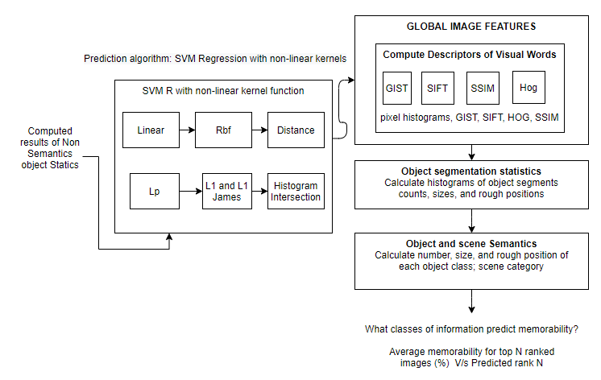

**PSEUDOCODE FOR WHAT CLASSES OF IMAGE PREDICT MEMORABILITY?**

Step 1: Input the system with Computed results of Non Semantics Object Statistics

Step 2: Use Prediction algorithm for effective correlation with memorability score

1. Calculate Support Vector Machine Regression with Non-linear Kernel Functions.
2. Use the computation of kernel functions with global image features

a) Compute Descriptors of Visual words

Step 3: Calculate histograms of object segments, count, sizes and rough positions for object segmentation statistics

Step 4: Calculate number size and rough position of each object class scene category

Output:

Average memorability for top N ranked images(%) V/s Predicted Rank N

Thus analysis of object semantic regressions demonstrate that if a system knows which objects an image contains, it is able to predict memorability with a performance not too far from human consistency. Semantic images contribute for image memorability.

**DETAILED ARCHITECTURE DIAGRAM MODULE WISE SPILT UP MEMORABILITY MAP(6)**

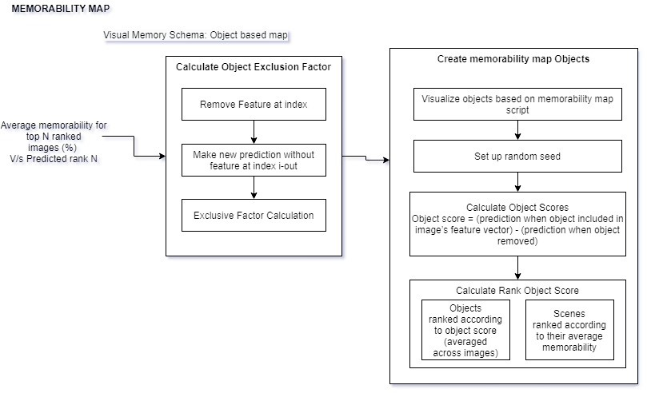

**PSEUDOCODE FOR MEMORABILITY MAP**

Step 1: Input the system with the Average memorability for top ranked images (%) V/s Predicted rank N

Step 2:Calculate the object exclusion Factor

a. Remove the feature at index

b. Make the new prediction without features

c. Get the Exclusive Factor Calculation

Step 3 :Create Memorability map objects

a. Visualize objects based on memorability map

Step 4: Calculate Object Scores

Step 5 : Calculate Rank Object Scores

Output: Visualizations of Objects ranked according to object score (averaged across image),Scenes ranked according to their average memorability

**It helps to visualize what content makes an image memorable?**

**DETAILED ARCHITECTURE DIAGRAM MODULE WISE SPILT UP AUTOMATIC PREDICTIONS(7)**

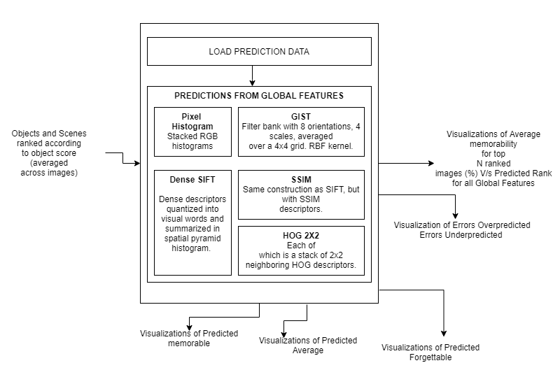

**PSEUDOCODE FOR AUTOMATIC PREDICTIONS**

Step 1: Input the system with the object and scenes ranked according to the object score

Step 2:Load the Prediction Data using Prediction function

Step3 :Make Predictions from the Global Features using the following:

1. Pixel Histograms
2. GIST
3. Dense SIFT
4. SSIM
5. HOG 2x2

Output:

1. Visualizations of Average memorability for top N ranked Images V/s Predicted Rank for all global features
2. Visualization of Predicted
   1. Memorable
   2. Average
   3. Forgettable
3. Visualization of Errors Over Predicted and Errors Under Predicted

**f. IMPLEMENTATION DETAILS**

To Compute features of new images, predicting their memorability, and replicating the results.

**DATASET DESCRIPTION :**

**The IMAGE datasets:**

Database: 2222 photographs from SUN database: Includes target and filler images. It includes Pre computed features and annotations. Memorability measurements are taken from "Memory Game“.

**TEST CASES:**

* **Natural Scene Images**
* **Outdoor Images**
* **Indoor Images**
* **Focused Images**

**We feed the system with the combination of the images and test for its accurate predictability**

**SNAPSHOTS/RESULTS**

**Feature Extraction**

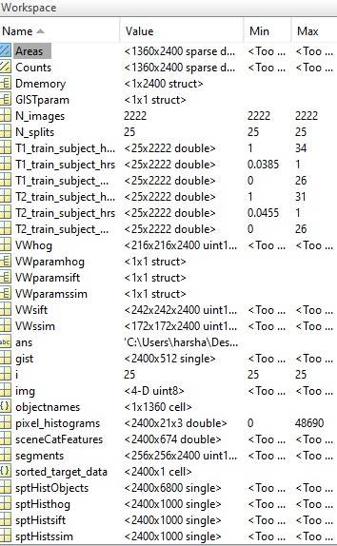

**MEMORABILITY MEASURE**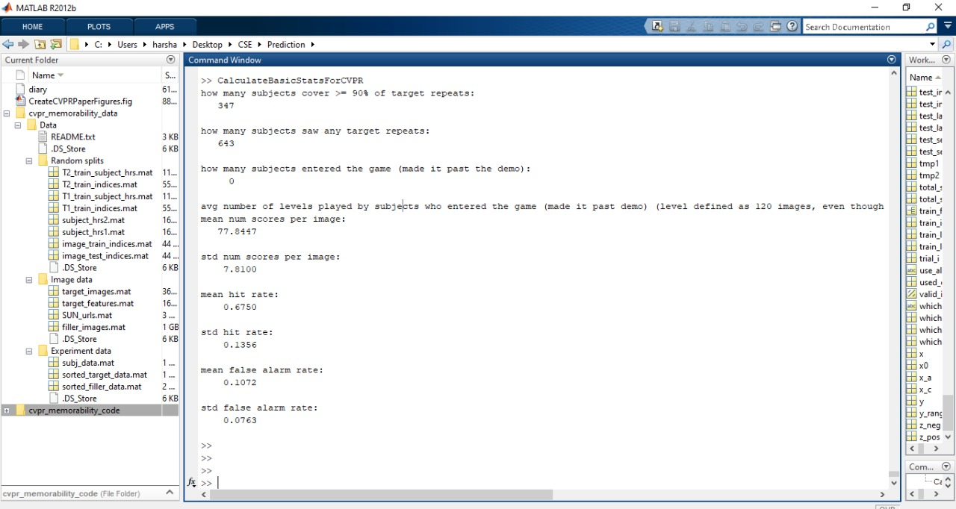

MODULE 1 VISUALIZATION

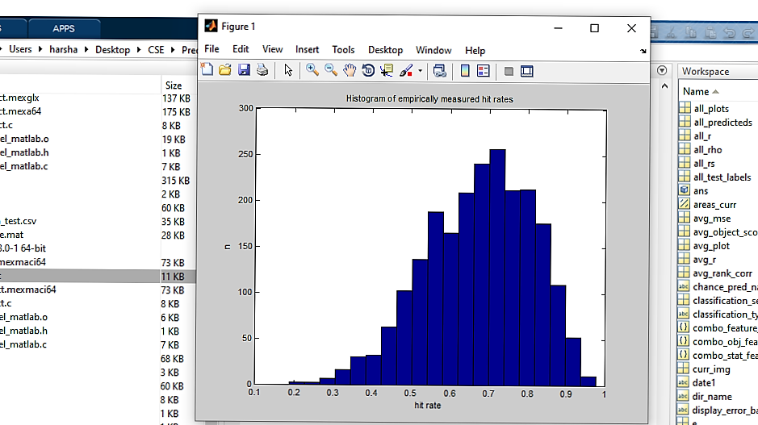

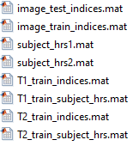

**DATABASE SAMPLE SET**

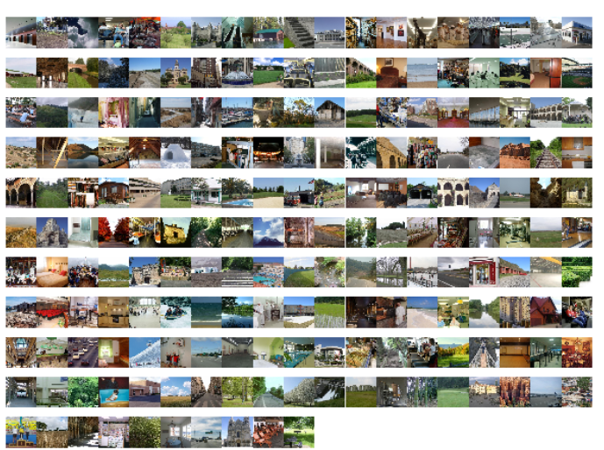

**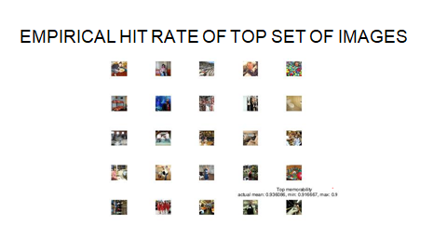  
**











**g. EVALUATION METRICS**

1.Memorability = probability of correctly detecting a repeat after a single view of an image in a long stream.

2. Object score = (prediction when object included in image’s feature vector) - (prediction when object removed)

3. Hit Rate = Number of Images chosen correctly as remembered by observers ÷ Total number of their occurrences as a repeat image.

4. False Alarm Rate (FAR) = False Hits of an Image ÷ Total number of its occurrences as a second-stage-filler (i.e. non-repeat) image.

5. Spearman linear correlation coefficient c denoted as ρ2D 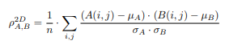

6. Mutual information (MI) criterion, denoted as IA,B

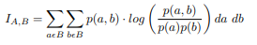

7. A confidence scale allows us to produce ROC curves that provided us with a sensitivity measure of the experiment.

8.Precision = RETREL / RET

9. recall = RETREL / REL

10. RET -The set of all items the system has retrieved for a specific inquiry

11. REL-The set of relevant items for a specific inquiry

12. RETREL-The set of the retrieved relevant items

**REFERENCES**

[1] E. Tulving, Organization of memory. Academic Press, New York, 1972, ch. Episodic and semantic memory, pp. 381–403.

[2] T. F. Brady, T. Konkle, and G. A. Alvarez, “A review of visual memory capacity: Beyond individual items and toward structured representations,” Journal of Vision, vol. 11, no. 5, pp. 1–34, 2011.

[3] L. Standing and P. Smith, “Verbal-pictorial transformations in recognition memory.”Canadian Journal of Psychology, vol. 29, no. 4, pp.316–326, 1975.

[4] P. Isola, D. Parikh, A. Torralba, and A. Oliva, “Understanding the intrinsic memorability of images,” in conference on Neural information processing Systems (NIPS), 2011.

[5] Z. Bylinskii, P. Isola, C. Bainbridge, A. Torralba, and A. Oliva, “Intrinsic and extrinsic effects on image memorability,” Vision Research, vol. 116, pp. 16–178, 2015.

[6] A. Oliva and A. Torralba, “Modeling the shape of the scene: A holistic representation of the spatial envelope,” Int. J. Computer. Vision, vol. 42, no. 3, pp. 145–175, May 2001